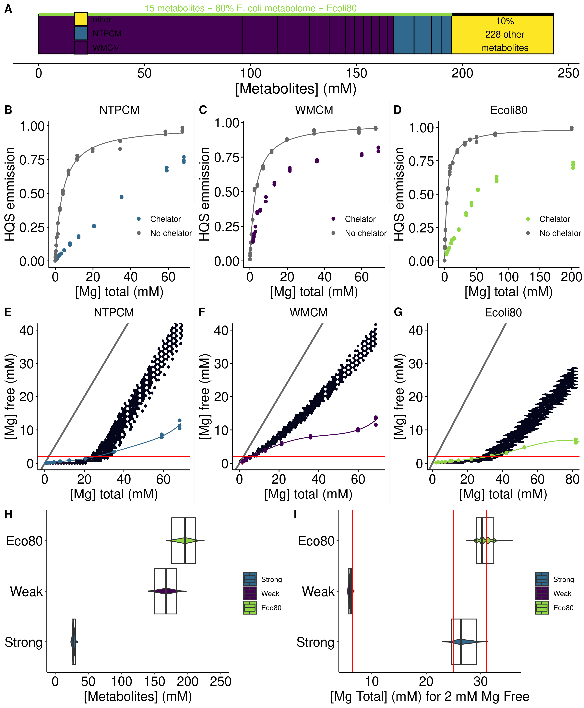

**Figure 1** *E. coli* metabolite and Mg2+ mixtures approximate single site binding near 2 mM free Mg2+. **(A)** E. coli metabolome molar composition. **(B-C)** Effect of Mg2+ on 8-hydroxyquinoline-5-sulphonic acid emission with and without mixtures of metabolites that chelate Mg2+. Grey lines represent fits to determine the binding constant for Mg2+ and HQS. **(E-F)** Effect of the total Mg2+ concentration on the free Mg2+ concentration with mixtures of metabolites that chelate Mg2+. Free Mg2+ was calculated using HQS emission and the binding constant for Mg2+ and HQS. Grey lines represent the free Mg2+ concentration in the absence of chelators (free Mg2+ = total Mg2+). Hex bins represent a statistical simulation based on experimental errors in KD determination, experimental errors in reagent concentrations, and single site binding. **(H)** Concentration of metabolites in each artificial cytoplasm. Box plots represent means and 95% confidence intervals from statistical simulation based on experimental errors in reagent concentrations . Violin plots represent the distribution for the same simulation. **(I)** Total Mg2+  required to have 2 mM free Mg2+. Box plots represent means and 95% confidence intervals from statistical simulation based on experimental errors in KD determination, experimental errors in reagent concentrations, and single site binding. Violin plots represent the distribution for the same simulation. Red lines represent the total Mg2+  required to have 2 mM free Mg2+ in each artificial cytoplasm as determined in panels E-F.

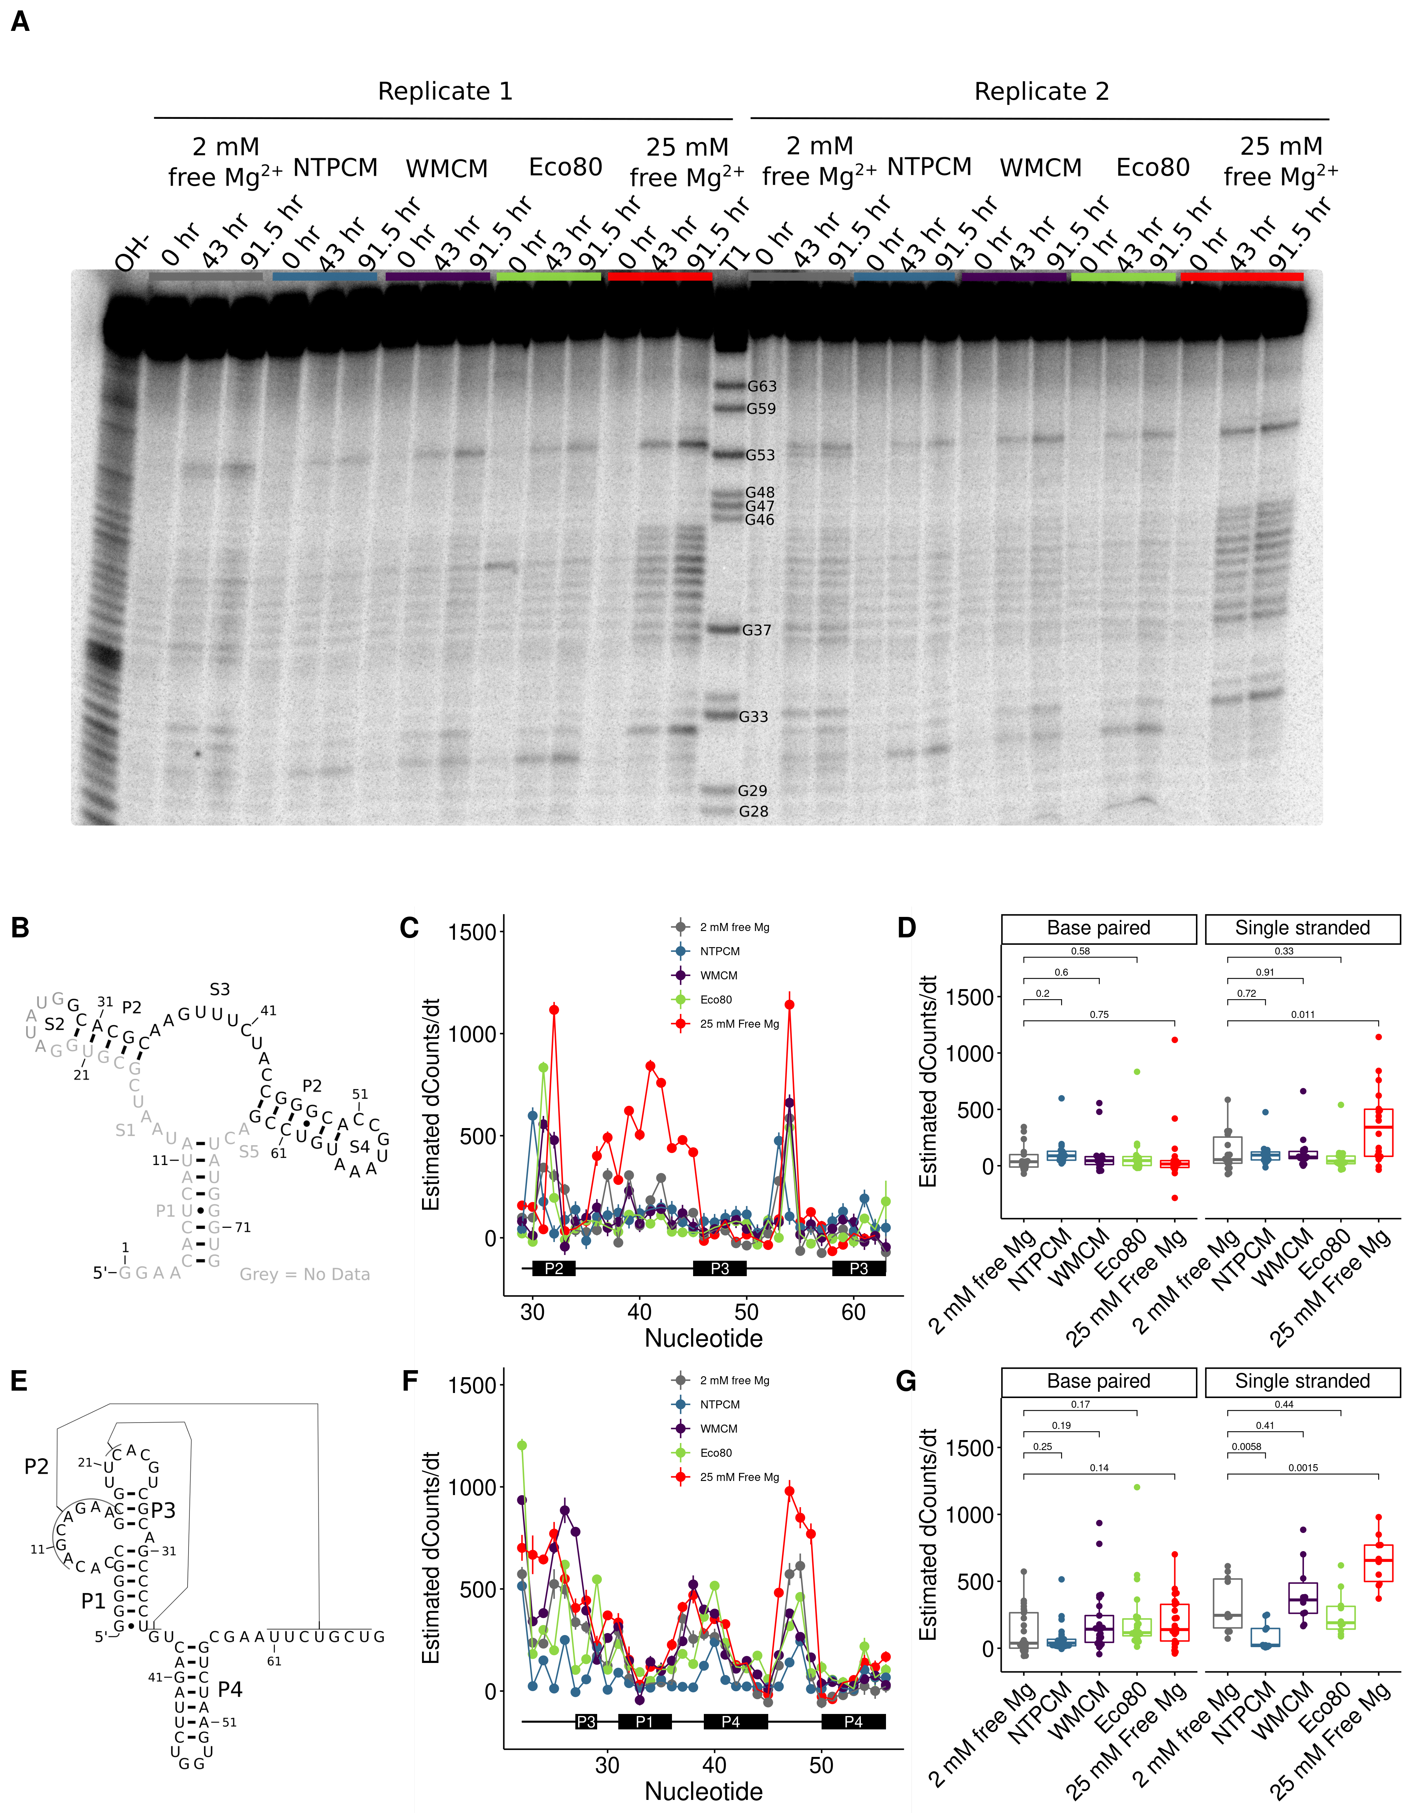

**Figure 2** *E. coli* metabolite and Mg2+ mixtures stabilize the chemical structure of RNA. **(A)** Raw degradation assay gel image for the Guanine riboswitch aptamer incubated in artificial cytoplasms at 37 °C and pH 7. The OH- lane contains a hydrolysis ladder which cleaves after every nucleotide and T1 contains the RNA treated with T1 ribonuclease which cleaves after every G. Enough Mg2+ was added to each artificial cytoplasm to have 2 mM Mg2+  as determined in Figure 1. **(B)** Secondary structure of the guanine riboswitch aptamer. **(C)** Estimated increase in counts as a function of time at each residue in different solution conditions as a function of location in the RNA. **(D)** Estimated increase in counts as a function of time in different conditions grouped by paired and unpaired bases. Significance was determined using a student’s t-test. **(E)** Secondary structure of the cleaved human CPEB3 HDV ribozyme. **(C)** Estimated increase in counts as a function of time at each residue in different solution conditions as a function of location in the RNA. **(D)** Estimated increase in counts as a function of time in different conditions grouped by paired and unpaired bases. Significance was determined using a student’s t-test.

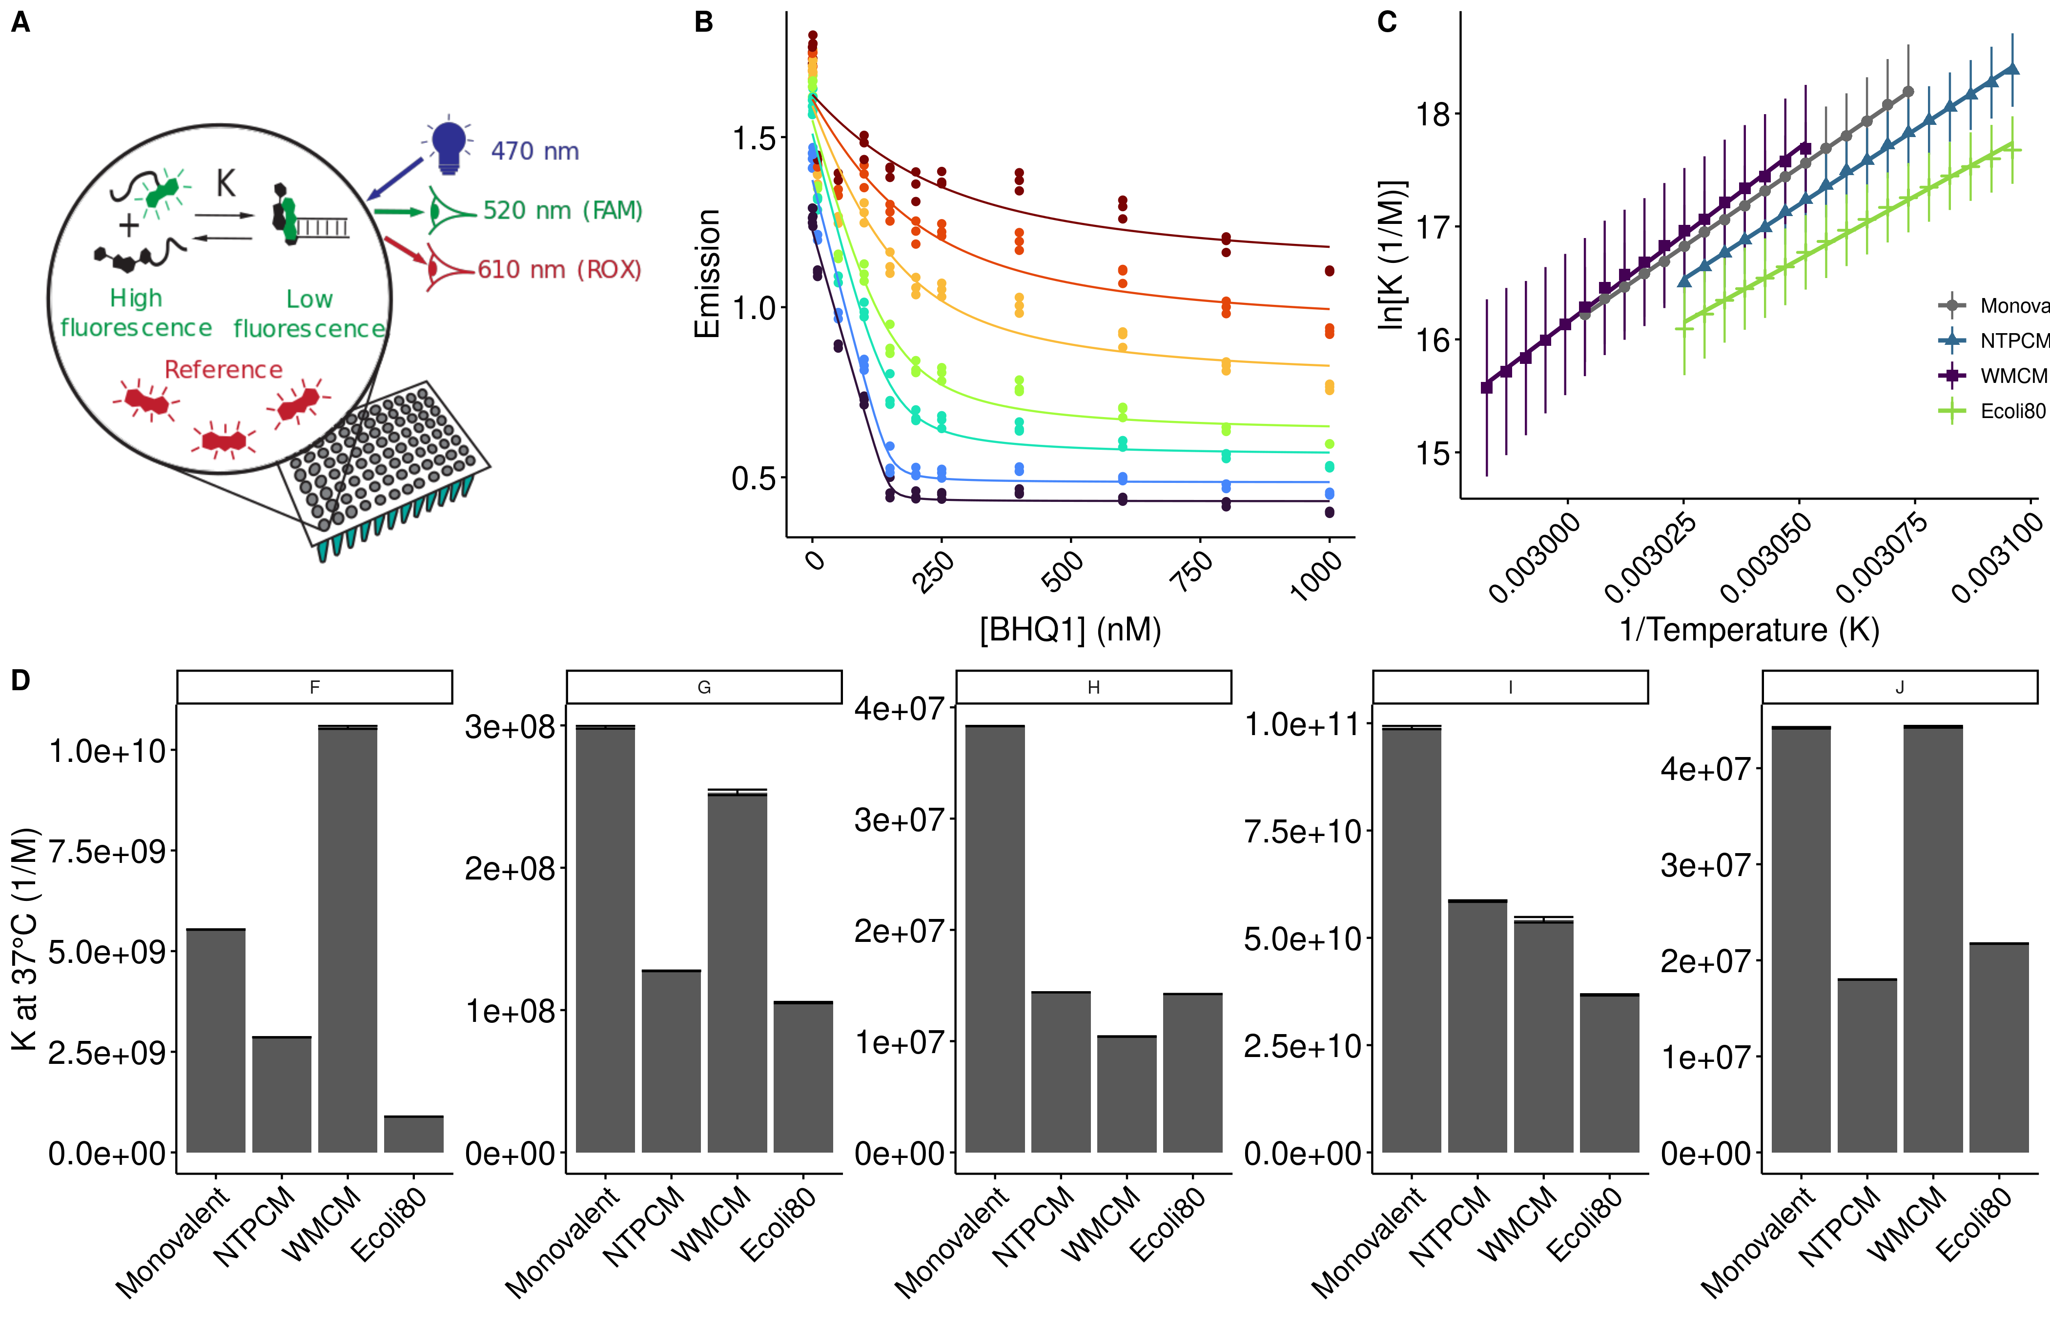**Figure 3** *E. coli* metabolite and Mg2+ mixtures destabilize RNA secondary structure.

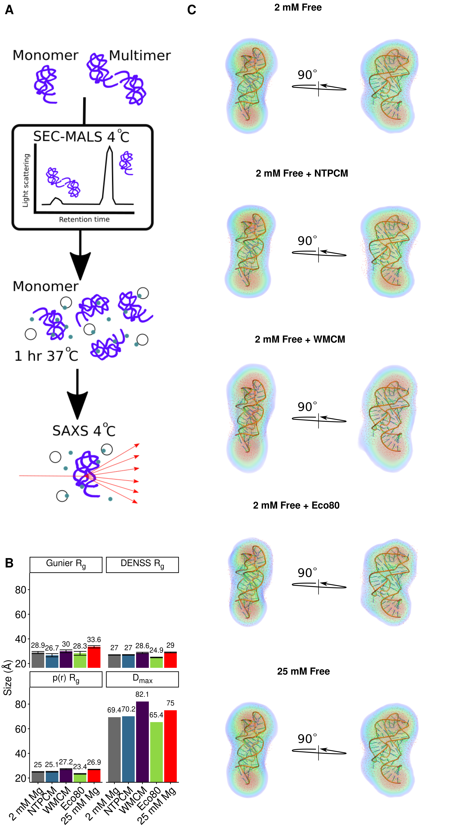

**Figure 4** *E. coli* metabolite and Mg2+ mixtures increase functional RNA compactness.

Table 1. The top 14 most abundant metabolites that comprise 80% of the E. coli metabolome.

|  |  |  |  |
| --- | --- | --- | --- |
| Metabolite | Conc. (mM) | K’D  (mM) | Chelation stength |
| ATP | 9.63 | 0.276 (0.272 to 0.279)a | Strongc |
| UTP | 8.29 | 0.238 (0.230 to 0.245)a | Strongc |
| GTP | 4.87 | 0.201 (0.195 to 0.208)a | Strongc |
| dTTP | 4.62 | 0.160 (0.153 to 0.166)a | Strongc |
| L-Glutamic acid | 96 |  | Weakc |
| Glutathione | 16.6 |  | Weakc |
| Fructose 1,6-BP | 15.2 | 5.9 (5.6 to 6.2)a | Weakc |
| UDP-GlcNAC | 9.24 | 29.0 (28.4 to 29.6)a | Weakc |
| Glucose 6-P | 7.88 | 17.3 (16.8 to 17.7)a | Weakc |
| L-Aspartic acid | 4.23 |  | Weakc |
| L-Valine | 4.02 |  | Weakc |
| L-Glutamine | 3.81 |  | Weakc |
| 6-P-gluconic acid | 3.77 | 14.4 (5.6 to 6.2)a | Weakc |
| Pyruvic acid | 3.66 |  | Weakc |
| Dihydroxyacetone phosphate | 3.06 | 19.7 (19.2 to 20.2)a | Weakc |

aDetermined at 37 °C with Isothermal titration calorimetry. Error is the propagated standard error in the fit parameter.

cmetabolites with KDs for Mg2+ less than 2 mM are considered strong Mg2+ chelators.

Table 2. Stability of RNA helices in *E. coli* **metabolite mixtures.**

|  |  |  |  |  |  |  |  |
| --- | --- | --- | --- | --- | --- | --- | --- |
| Helix | Sequence (5'-FAM/ BHQ1-3') | AU  content | Condition | dH (kcal/mol) | dS (cal/mol/K) | dG (kcal/mol) | ddG (kcal/mol) |
| F | CGCAUCCU/AGGAUGCG | 0.38 | 2 mM free | -55.9 (0.2) | -136.0 (0.7) | -13.82 (0.01) |  |
| NTPCM | -52.2 (0.4) | -125 (1) | -13.41 (0.02) | 0.41 (0.02) |
| WMCM | -61.4 (0.8) | -152 (2) | -14.22 (0.05) | -0.40 (0.05) |
| Ecoli80 | -44.5 (0.7) | -102 (2) | -12.70 (0.04) | 1.13 (0.04) |
| G | CCAUAUCA/UGAUAUGG | 0.63 | 2 mM free | -53.4 (1.0) | -133 (3) | -12.02 (0.04) |  |
| NTPCM | -42.9 (0.5) | -101 (1) | -11.50 (0.02) | 0.52 (0.04) |
| WMCM | -53 (2) | -132 (7) | -11.9 (0.1) | 0.10 (0.01) |
| Ecoli80 | -57 (2) | -146 (5) | -11.38 (0.05) | 0.64 (0.06) |
| H | CCAUAUUA/UAAUAUGG | 0.75 | 2 mM free | -53.5 (0.4) | -137 (1) | -10.76 (0.01) |  |
| NTPCM | -45.0 (0.2) | -112.5 (0.5) | -10.158 (0.002) | 0.60 (0.01) |
| WMCM | -43 (2) | -107 (5) | -9.94 (0.02) | 0.80 (0.02) |
| Ecoli80 | -41.3 (0.2) | -100.4 (0.7) | -10.15 (0.01) | 0.61 (0.01) |
| I | CGGAUGGC/GCCAUCCG | 0.25 | 2 mM free | -71.1 (0.8) | -179 (2) | -15.6 (0.06) |  |
| NTPCM | -70.4 (0.6) | -177 (2) | -15.28 (0.05) | 0.32 (0.08) |
| WMCM | -65.5 (2) | -162 (7) | -15.2 (0.2) | 0.4 (0.2) |
| Ecoli80 | -69.7 (0.8) | -176 (3) | -14.0 (0.1) | 0.61 (0.08) |
| J | CGUAUGUA/UACAUACG | 0.63 | 2 mM free | -63.2 (0.9) | -169 (3) | -10.85 (0.02) |  |
| NTPCM | -59 (1) | -157 (4) | -10.30 (0.01) | 0.55 (0.02) |
| WMCM | -67 (1) | -180 (3) | -10.85 (0.02) | 0.00 (0.03) |
| Ecoli80 | -61 (1) | -164 (3) | -10.41 (0.01) | 0.44 (0.02) |